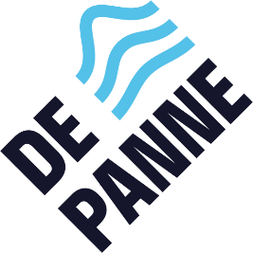
Regulations Summer Bee Cycling Route – De Panne
1. Organisation
The cycling route is organised by the Local Authority of De Panne.
2. Period
The treasure hunt runs from 29/05/2026 until 30/09/2026 inclusive.
3. Participation
- Participation is open to everyone.
- Participation is free of charge.
4. How it works
- Participants follow the indicated route and answer the questions.
- Answers must be written on the official entry form.
- Please also complete your name, address and telephone number on the form.
5. Submission
- The entry form must be submitted to Toerisme De Panne no later than 30 September 2026.
- Winners will receive a Pannebon or a gift basket.
- Winners will be notified personally via the email address or telephone number provided.
- Prizes that have not been collected before 31 December 2026 will revert to the ownership of the local authority.
7. Privacy
The personal data provided will only be used for the purpose of this competition and will not be shared with third parties.
8. Miscellaneous provisions
- By taking part in the treasure hunt, participants agree to these regulations.
- In the event of a dispute, the decision of the organiser is binding.
- The local authority cannot be held liable for any accidents.

